Event Data Quality & Analysis

BY: LISHA.M

Create events.csv
We need approximately 15–20 records.
Our dataset will deliberately contain:
- 20 physical rows
- 1 duplicate event_id
- 3 null durations
- inconsistent event_type casing
- inconsistent device casing
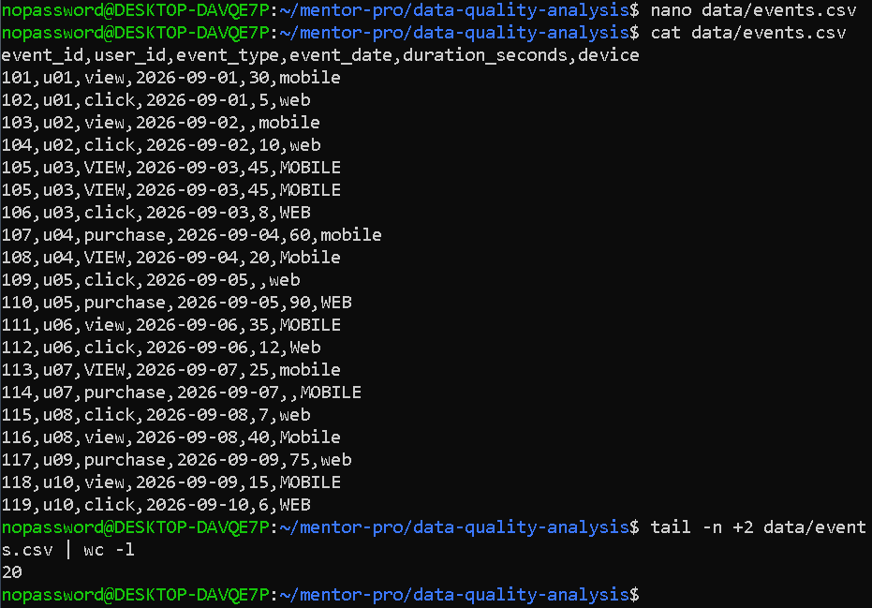

Create build.sbt
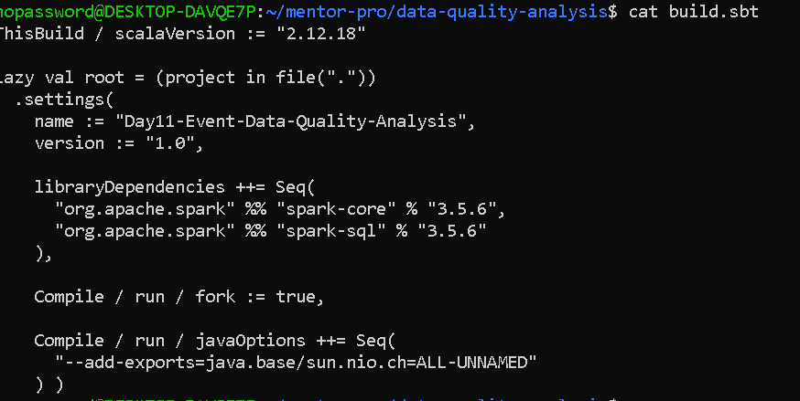
cat src/main/scala/EventDataQualityAnalysis.scala
import org.apache.spark.sql.{SparkSession, DataFrame}
import org.apache.spark.sql.functions._
import org.apache.spark.sql.types._
object EventDataQualityAnalysis {
def main(args: Array[String]): Unit = {
// ---------------------------------------------------------
// 1. Create SparkSession
// ---------------------------------------------------------
val spark = SparkSession.builder()
.appName("Event Data Quality and Analysis")
.master("local[*]")
.getOrCreate()
spark.sparkContext.setLogLevel("WARN")
println("\n========== EVENT DATA QUALITY & ANALYSIS ==========\n")
// ---------------------------------------------------------
// 2. Define suitable schema
// ---------------------------------------------------------
val eventSchema = StructType(Seq(
StructField("event_id", IntegerType, nullable = false),
StructField("user_id", StringType, nullable = false),
StructField("event_type", StringType, nullable = true),
StructField("event_date", DateType, nullable = true),
StructField("duration_seconds", IntegerType, nullable = true),
StructField("device", StringType, nullable = true) ))
// ---------------------------------------------------------
// 3. Read CSV
// ---------------------------------------------------------
val inputPath = "data/events.csv"
val events = spark.read
.option("header", "true")
.option("dateFormat", "yyyy-MM-dd")
.schema(eventSchema)
.csv(inputPath)
println("========== SCHEMA ==========")
events.printSchema()
println("\n========== SAMPLE ROWS ==========")
events.show(10, truncate = false)
println("\n========== RECORD COUNT ==========")
println(s"Total records: ${events.count()}")
// ---------------------------------------------------------
// 4. Null-count report
// ---------------------------------------------------------
println("\n========== NULL COUNT REPORT ==========")
val nullReport = events.select(
events.columns.map(
c => sum(when(col(c).isNull, 1).otherwise(0)).alias(c)): _*)
nullReport.show(false)
// ---------------------------------------------------------
// 5. Find duplicate event_id values
// ---------------------------------------------------------
println("\n========== DUPLICATE EVENT IDs ==========")
val duplicateEventIds = events
.groupBy("event_id")
.count()
.filter(col("count") > 1)
duplicateEventIds.show(false)
// ---------------------------------------------------------
// 6. Remove duplicate records
// ---------------------------------------------------------
val deduplicatedEvents = events.dropDuplicates("event_id")

println("\n========== AFTER DUPLICATE REMOVAL ==========")
println(s"Records before deduplication: ${events.count()}")
println(s"Records after deduplication: ${deduplicatedEvents.count()}")
// ---------------------------------------------------------
// 7. Standardize event_type and device
// ---------------------------------------------------------
val standardizedEvents = deduplicatedEvents
.withColumn(
"event_type",
lower(trim(col("event_type")))
)
.withColumn(
"device",
lower(trim(col("device")))
)
println("\n========== STANDARDIZED DATA ==========")
standardizedEvents.show(20, truncate = false)
// ---------------------------------------------------------
// 8. Handle missing duration_seconds
// ---------------------------------------------------------
val medianDuration = standardizedEvents
.stat
.approxQuantile(
"duration_seconds",
Array(0.5),
0.0
)(0)
println(s"\nMedian duration used for missing values: $medianDuration seconds")
val cleanedEvents = standardizedEvents
.withColumn(
"duration_seconds",
when(
col("duration_seconds").isNull,
lit(medianDuration.toInt)
).otherwise(col("duration_seconds"))
)
println("\n========== CLEANED DATA ==========")
cleanedEvents.show(20, truncate = false)

// ---------------------------------------------------------
// 9. Verify remaining nulls
// ---------------------------------------------------------
println("\n========== NULL COUNT AFTER CLEANING ==========")
val finalNullReport = cleanedEvents.select(
cleanedEvents.columns.map(
c => sum(when(col(c).isNull, 1).otherwise(0)).alias(c)
): _*
)
finalNullReport.show(false)
// ---------------------------------------------------------
// 10. Event count and average duration by event_type
// ---------------------------------------------------------
println("\n========== EVENT COUNT & AVERAGE DURATION BY EVENT TYPE ==========")
val eventTypeSummary = cleanedEvents
.groupBy("event_type")
.agg(
count("*").alias("event_count"),
round(avg("duration_seconds"), 2).alias("average_duration_seconds")
)
.orderBy("event_type")
eventTypeSummary.show(false)
// ---------------------------------------------------------
// 11. Event count by event_date
// ---------------------------------------------------------
println("\n========== EVENT COUNT BY DATE ==========")
val eventDateSummary = cleanedEvents
.groupBy("event_date")
.count()
.withColumnRenamed("count", "event_count")
.orderBy("event_date")
eventDateSummary.show(false)
// ---------------------------------------------------------
// 12. Explain Spark execution plan
// ---------------------------------------------------------

println("\n========== EXPLAIN PLAN ==========")
eventTypeSummary.explain(true)
println("\n========== PROJECT COMPLETED ==========\n")
spark.stop()}}
OUTPUT---
- Show the schema, sample rows, and record count.

Schema
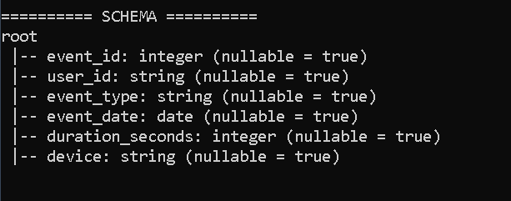

Sample rows
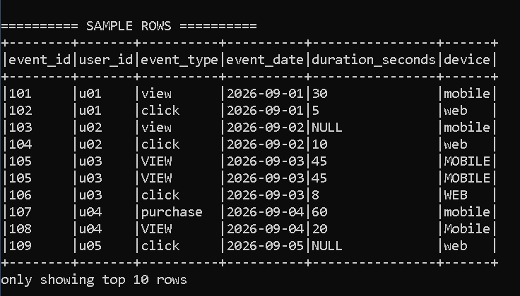

Record count
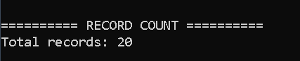

- Create a null-count report for each column.
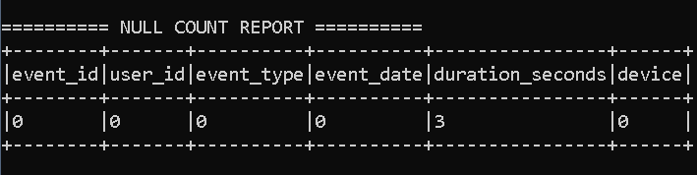

The only column containing null values was duration_seconds, which had three missing values. The other columns had zero nulls."

- Find duplicate event_id values and remove duplicate records.

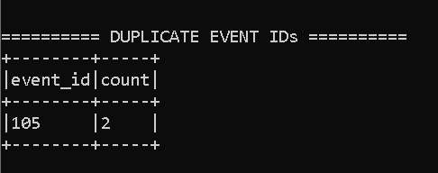

This shows only event_id 105 has appeared twice(duplicate).

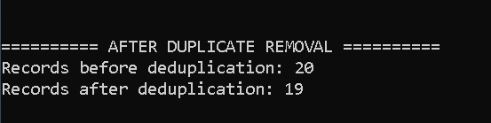

There are 20 data before removing duplicate data, after it became 19.
I grouped the data by event_id and counted each ID. Event ID 105 occurred twice, so it was identified as a duplicate. I then used dropDuplicates on event_id. The record count decreased from 20 to 19.

- Standardize event_type and device values.

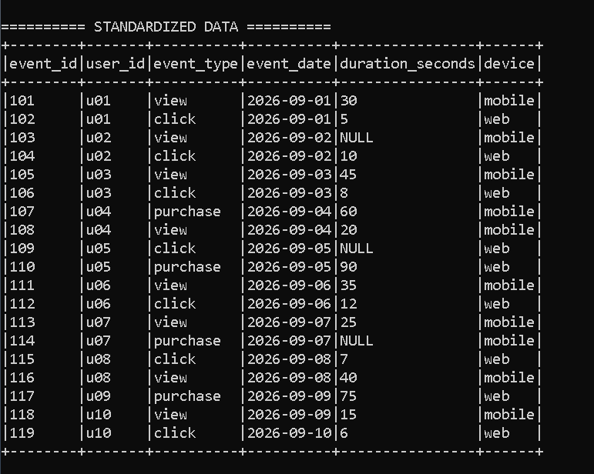

Standardized output confirms that all values have been converted to lowercase. This ensures that values such as VIEW, View and view are treated as the same event type, and MOBILE, Mobile and mobile are treated as the same device.
We used: lower(trim(col("event_type")) and lower(trim(col("device")))

- Handle missing duration_seconds and document the chosen approach.

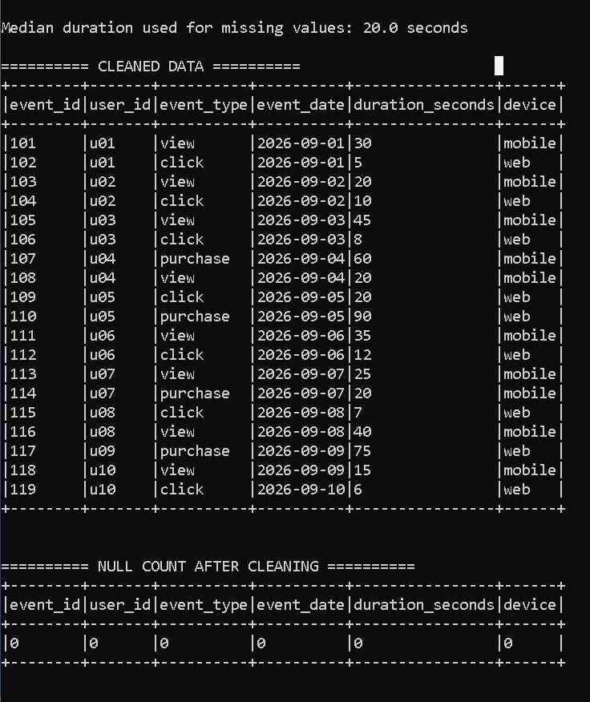
There were three missing duration values. I chose median imputation instead of deleting those records because the events themselves are still valid. Spark calculated the median duration as 20 seconds, and I replaced the three missing values with 20. Because the median represents the middle of the distribution.
approxQuantile("duration_seconds", Array(0.5), 0.0)

- Create event count and average duration by event_type.

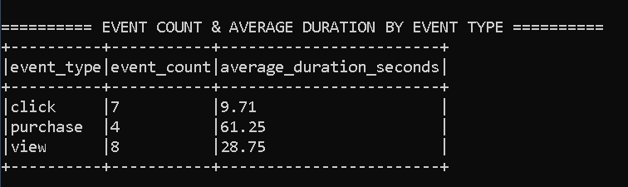

After cleaning the data, It grouped the records by event_type. There are 8 view events, 7 click events, and 4 purchase events. I also calculated the average duration for each event type.

- Create event count by event_date.

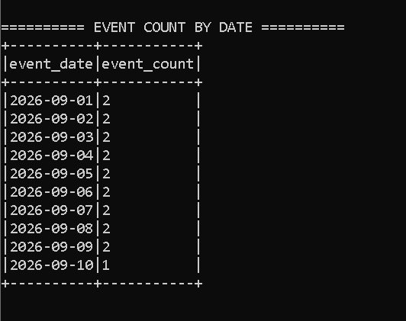

I grouped the cleaned data by event_date and counted the events for each date. Most dates contain two events, while September 10 contains one event. The total across all dates is 19, matching the cleaned record count.

- Run explain() on one summary and identify a likely shuffle operation.

Execution Plan Analysis
The explain(true) command was used to inspect the execution plan of the event-type summary. Spark displayed four stages of planning: Parsed Logical Plan, Analyzed Logical Plan, Optimized Logical Plan, and Physical Plan.
The physical plan shows that Spark reads the CSV using FileScan, performs deduplication based on event_id, and then performs aggregation based on event_type.
A likely shuffle operation is visible as:
Exchange hashpartitioning(event_type, 200)
This occurs because the groupBy("event_type") operation requires Spark to redistribute records across partitions so that records with the same event type can be processed together.
Another Exchange operation occurs for event_id because duplicate records must be brought together during dropDuplicates("event_id").
The HashAggregate operations represent the calculation of event counts and average durations. The final Sort corresponds to ordering the summary by event_type.

